**COMPSOFT TECHNOLOGIES**

An

Internship Report

On

**“Quora For Engineering Students”**

Bachelor of Engineering

In

Computer Science and Engineering

**Submitted By: Belliappa K E (4MC18CS020)**



**Malnad College of Engineering, Hassan**

**2021-2022**

**About The Company**

We are a digital service provider that aims to provide software, designing and marketing solutions to individuals and businesses, we believe that service and quality is the key to success

We provide all kinds of technological and designing solutions from Billing Software to Web Designs or any custom demand that you may have. Experience the service like none other!

Some of our services include:

**Development** - We develop responsive, functional and super-fast websites.

We keep User Experience in mind while creating websites. A website should load quickly and should be accessible even on a small view-port and slow internet connection.

**Mobile Application** - We offer a wide range of professional Android, iOS & Hybrid app development services for our global clients, from a start up to a large enterprise.

**Design** - We offer professional Graphic design, Brochure design & Logo design. We are experts in crafting visual content to convey the right message to the customers.

**Consultancy** - We are here to provide you with expert advice on your design and development requirement.

**Videos** - We create a polished professional video that impresses your audience.

**Table of Contents**

Overview of the Project 4

What is Quora?? 4

Tools Used 5

Implementation 6-11

Snapshots 12-13

References 14

About My Team 14

**Overview of the Project**

**Project Name: Quora For Engineering Students**

**Team Members: Belliappa K E - 4MC18CS020**

**Anand Sunkad – 4MC18CS010**

This project is based on Web Development And its Applications. The main objective of this project is to learn the implementation of HTML, CSS and JavaScript. The basic webpage of this project is created using HTML and styling of the webpage is done using CSS.

This webpage is about the Question and Answer for the Engineering Students where students can easily resolve their queries related to Engineering where every user can ask a question and also provide answers to others questions.

**What is Quora??**

Quora is a question and answer website where people go to find information. Every piece of content on the site is generated by users, meaning it is created, edited, and organized by the same people that use the website.

In a few words, Quora is a questions and answers website. It was founded in 2009 by two ex-Facebook employees, and was actually [almost called Quiver](https://www.quora.com/How-did-Adam-DAngelo-and-Charlie-Cheever-come-up-with-the-name-Quora/answer/Charlie-Cheever) instead. Nonetheless, this Q&A website has seen tremendous growth since its inception, where it’s been quite aptly [described as](https://www.vox.com/recode/2019/5/16/18627157/quora-value-billion-question-answer), "a more organized Yahoo Answers, a classier Reddit, [and] an opinionated Wikipedia” according to Vox’s Recode journalist, Theodore Schleier.

The primary function of Quora works quite simply: You can search questions to get answers or provide answers to questions on the site. That said, the biggest concern about this type of crowd-sourced information is whether the information given is actually factual, or at least, completely correct. Luckily, many of these woes are eased due to the fact that industry experts often use Quora to provide answers. We’ll dive into that a bit further down.

**TOOLS USED**

### Software Requirements

* Visual Studio Code 2019.
* Google Chrome or Microsoft Edge of latest version.
* Front End: HTML, CSS, JS (optional)
* Linux 7.1 or Windows XP/7/8/10 OS or Mac OS

### Hardware Requirements

* Pentium 200-MHz computer with a minimum of 64 MB of RAM (128 MB of RAM recommended).
* Monitor with a refresh rate of at least 40Hz for a smooth GUI experience (optional).

**IMPLEMENTATION**

**Source Code: login.html**

<?php

session_start();

if(isset($_POST['submit'])) {

    include 'db-include.php';

    //knowing the entered variables

    $uid = $_REQUEST['uid'];

    $pwd = $_REQUEST['pwd'];

    //Error Handling

    //check if the input is empty

    if (empty($uid) || empty($pwd)) {

        header("Location: ../login_error.php");

        exit();

    }

    else{

        $sql = "SELECT * FROM users WHERE user_uid= '$uid' OR user_email='$uid';";

        $result= mysqli_query($conn, $sql);

        $resultCheck= mysqli_num_rows($result);

         if($resultCheck < 1){

            header("Location: ../login_error.php");

            exit();

        }

        else {

            if($row=mysqli_fetch_assoc($result)){

                //de-hash the password and then compare

                $hashedPwdCheck = password_verify($pwd, $row['user_pwd']);

                if ($hashedPwdCheck == false){

                    header("Location: ../login_error.php");

                    exit();

                }

                elseif ($hashedPwdCheck == true) {

                    //we use else if if the value turns out to be a value than a boolean

                    $_SESSION['u_id'] = $row['user_id'];

                    $_SESSION['u_first'] = $row['user_first'];

                    $_SESSION['u_last'] = $row['user_last'];

                    $_SESSION['u_email'] = $row['user_email'];

                    $_SESSION['u_uid'] = $row['user_uid'];

                    header("Location: ../../html/loginHome.php");

                    exit();

                }

            }

        }

    }

}

else {

    header("Location: ../login_error.php");

    exit();

}

**Signup.html**

<?php

if (isset($_POST['submit']))    {

    include_once 'db-include.php';

    $fname = $_REQUEST['fname'];//escape sequence for safety so users cant insert anything in the code

    $lname = $_REQUEST['lname'];

    $email = $_REQUEST['email'];

    $uid =  $_REQUEST['uid'];

    $pwd =  $_REQUEST['pwd'];

    $cpwd =  $_REQUEST['cpwd'];

    //handling error or Error Handlers

    //check for empty fields

    if (empty($fname) || empty($lname) || empty($email) || empty($uid) || empty($pwd) || empty($cpwd)){

        header("Location: ../signup_emptyFields.php");

        exit();

    }

    else{

        //if the characters in the name are valid(*handle the errors first)

        if (!preg_match("/^[a-zA-Z]*$/", $fname) || !preg_match("/^[a-zA-Z]*$/", $lname)){

            header ("Location: ../signup_validNames.php");

            exit();

        }

        else{

            //check it the email is valid

            if (!filter_var($email, FILTER_VALIDATE_EMAIL)){

                header("Location: ../signup_invalidEmail");

                exit();

            }

            else {

                //check if passw matches cpassword

                if($pwd != $cpwd)   {

                    header("Location: ../signup_passwordError");

                    exit();

                }

                else {

                    //Check if uid is unique

                    $sql = "SELECT * FROM users WHERE user_uid='$uid'";

                    $result = mysqli_query($conn, $sql);

                    $resultCheck = mysqli_num_rows($result);

                    if ($resultCheck > 0){

                        header("Location: ../signup_invalidUid.php");

                        exit();

                    }

                    else {//all credientials valid

                        //password hashing

                        $pwdHash = password_hash($pwd, PASSWORD_DEFAULT);

                        //final insertion in the database

                            $sql_ins = "INSERT INTO users (user_first, user_last, user_email, user_uid, user_pwd)  VALUES ('$fname', '$lname', '$email', '$uid', '$pwdHash');";

                            mysqli_query($conn, $sql_ins);

                            header("Location: ../login.php");

                            exit();

                    }

                }

            }

        }

    }

}

else {

    header("Location: ./signup.php");

    exit();

}

**Askquestion.php**

<!DOCTYPE html>

<html lang="en">

<head>

    <title>The Engineering Portal</title>

    <meta charset="UTF-8">

    <meta name="viewport" content="width=device-width , initial-scale= 1">

    <link rel="stylesheet" href="http://maxcdn.bootstrapcdn.com/bootstrap/3.3.7/css/bootstrap.min.css">

    <script src="https://ajax.googleapis.com/ajax/libs/jquery/3.2.1/jquery.min.js"></script>

    <script src="http://maxcdn.bootstrapcdn.com/bootstrap/3.3.7/js/bootstrap.min.js"></script>

    <link rel="stylesheet" href="sidebar.css">

    <link rel = "stylesheet" href="https://stackpath.bootstrapcdn.com/font-awesome/4.7.0/css/font-awesome.min.css">

    <link rel="stylesheet" href="../css/qanda.css" type="text/css">

    <link href="https://fonts.googleapis.com/css?family=Black+Han+Sans" rel="stylesheet">

    <link href="https://fonts.googleapis.com/css?family=Coda+Caption:800" rel="stylesheet">

    <link href="https://fonts.googleapis.com/css?family=Baloo+Paaji" rel="stylesheet">

</head>

<body>

<!--The navigation bar-->

<nav class="navbar navbar-inverse"> `

    <div class="container-fluid">

        <div class="navbar-header">

            <button type="button" class="navbar-toggle" data-toggle="collapse" data-target="#NavMenu">

                <span class="icon-bar"></span>

                <span class="icon-bar"></span>

                <span class="icon-bar"></span>

            </button>

            <a class="navbar-brand" href="home.html"><img src="../Homeimg/logo1.png" height="50" width="60"/></a>

        </div>

        <div class = "collapse navbar-collapse" id="NavMenu">

            <ul class="nav navbar-nav navbar-left">

                <li><a href="loginHome.php">HOME</a></li>

                <li><a href="loginaboutUs.php">ABOUT</a></li>

                <!-- <li><a href="#">REPORT</a></li>

                <li><a href="loginReview.php">REVIEWS</a></li>

                <li><a href="#">SUB-INFO</a></li> -->

                <li class="active"><a href="qanda.php">Q&A</a></li>

            </ul>

            <ul class="nav navbar-nav navbar-right">

                <form action="includes/logout-include.php" method="POST">

                    <li><button class="logout-btn" type="submit" name="submit">LOG OUT</button></li>

                </form>

            </ul>

    </div>

</nav>

<div class=" container-fluid text-justify" style="font-family: 'Black Han Sans',sans-serif; font-size: 200%">

     <?php

        session_start();

        if(isset($_SESSION['u_id'])){

            echo strtoupper ("HEY! HI ".$_SESSION['u_first'].":)" ."<div style='text-align: center'>QUESTION EVERYTHING</div>");

        }

    ?>

</div>

<div class="container-fluid" style="background-image: url(background-ques.jpg);background-repeat: no-repeat;">

    <div class="col-md-12 col-sm-12 col-xs-12">

        <form class="form-container" action="includes/askquestion-include.php" method="POST">

            <br><br><br>

            <h1 style="text-align: center;color: #FFF; font-family: 'Coda Caption', sans-serif;margin-top: 5px">ALL YOUR QUESTIONS WILL BE ANSWERED </h1>

            <br><br>

            <div class="form-group">

            <textarea class="form-control" style="min-width:100%;color: #FFF;border-color: black; background-color: transparent;font-size: 30px;border-width: medium; text-align: center;margin-left: 0% ;height: 20vh; font-family: 'Baloo Paaji', cursive;

                " type="text" id="form1" class="md-textarea form-control" rows="15" placeholder="ENTER YOUR QUESTION HERE" name="ques"></textarea><br>

            <button type="submit" name="submit" class="btn" style="background-color: transparent;float: right ;margin-bottom: 3vh">SUBMIT</button>

        </form>

    </div>

</div>

</div>

<footer class="container-fluid text-center">

    <div class="row">

        <div class="col-sm-4">

            <h3>Contact Us :</h3>

            <br>

            <h4>contact info</h4>

        </div>

        <div class="col-sm-4">

            <h3>Connect </h3>

            <a href="#" class="fa fa-facebook"></a>

            <a href="#" class="fa fa-google"></a>

            <a href="#" class="fa fa-youtube"></a>

            <a href="#" class="fa fa-linkedin"></a>

            <a href="#" class="fa fa-twitter"></a>

        </div>

        <div class="col-sm-4">

            <img src="../Homeimg/bunny.png" class="icon">

        </div>

    </div>

</footer>

</body>

</html>

**Loginsystem.sql**

CREATE TABLE users (

user_id int(10) not null AUTO_INCREMENT PRIMARY KEY,

user_first varchar(256) not null,

user_last varchar(256) not null,

user_email varchar(256) not null,

user_uid varchar(256) not null,

user_pwd varchar(256) not null

);

**Question.sql**

CREATE TABLE IF NOT EXISTS `admin` (

`user_id` int(11) NOT NULL,

`firstname` varchar(50) NOT NULL,

`lastname` varchar(50) NOT NULL,

`email` varchar(50) NOT NULL,

`username` varchar(50) NOT NULL,

`password` varchar(50) NOT NULL

) ENGINE=InnoDB AUTO_INCREMENT=4 DEFAULT CHARSET=latin1;

--

-- Dumping data for table `admin`

--

INSERT INTO `admin` (`user_id`, `firstname`, `lastname`, `email`, `username`, `password`) VALUES

(1, 'Billy', 'Revellame', 'revellame28@gmail.com', 'bluedcoffee', 'admin'),

(2, 'Clark', 'Banaag', 'banaaghub.com', 'clarkpogi', 'a1Bz20ydqelm8m1wql7c6f5bdc16b3748b481fb5ea98bd4ace'),

(3, 'admin', 'admin', 'admin@admin.com', 'admin', 'admin');

-- --------------------------------------------------------

--

-- Table structure for table `category`

--

CREATE TABLE IF NOT EXISTS `category` (

`cat_id` int(11) NOT NULL,

`cat_name` varchar(100) NOT NULL

) ENGINE=InnoDB AUTO_INCREMENT=11 DEFAULT CHARSET=latin1;

**IMPLEMENTATION**

**Snapshots:**

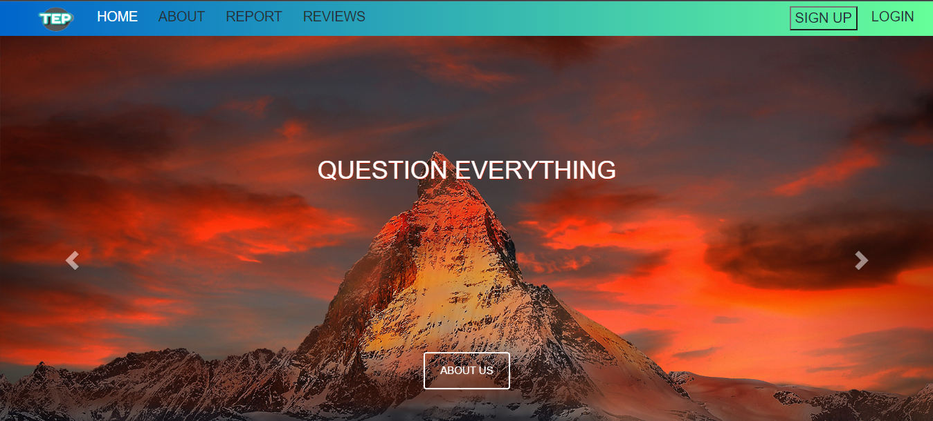

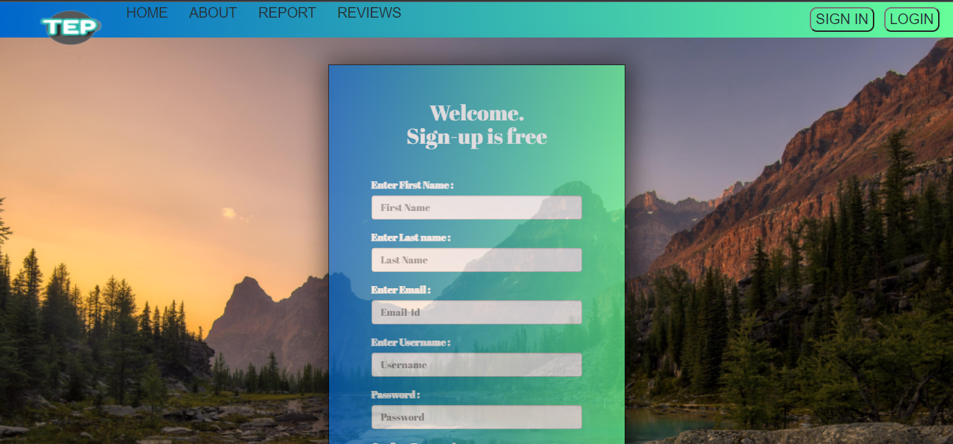

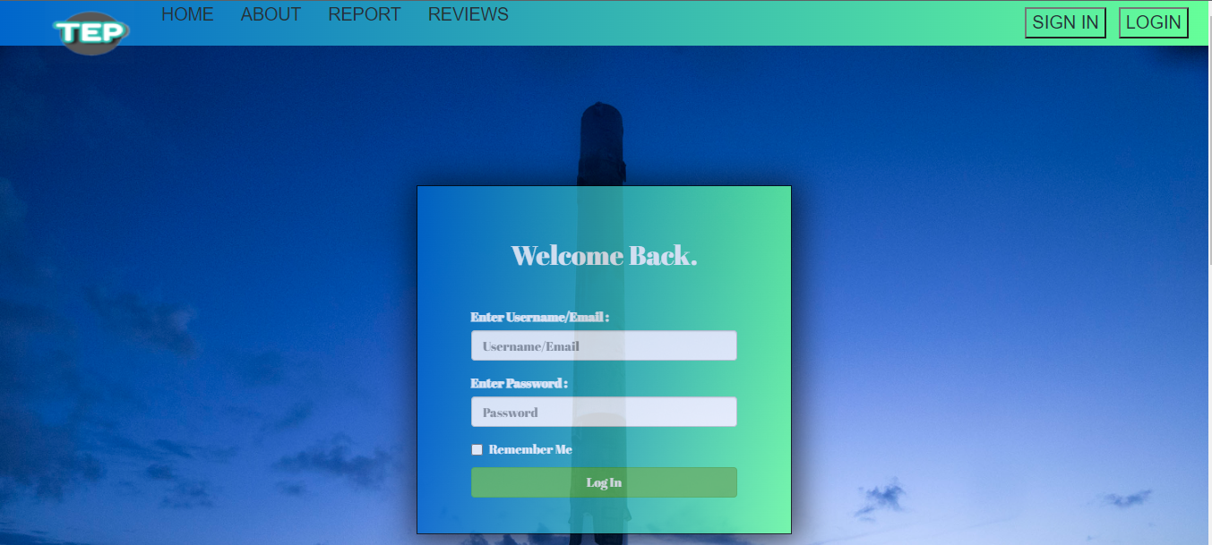

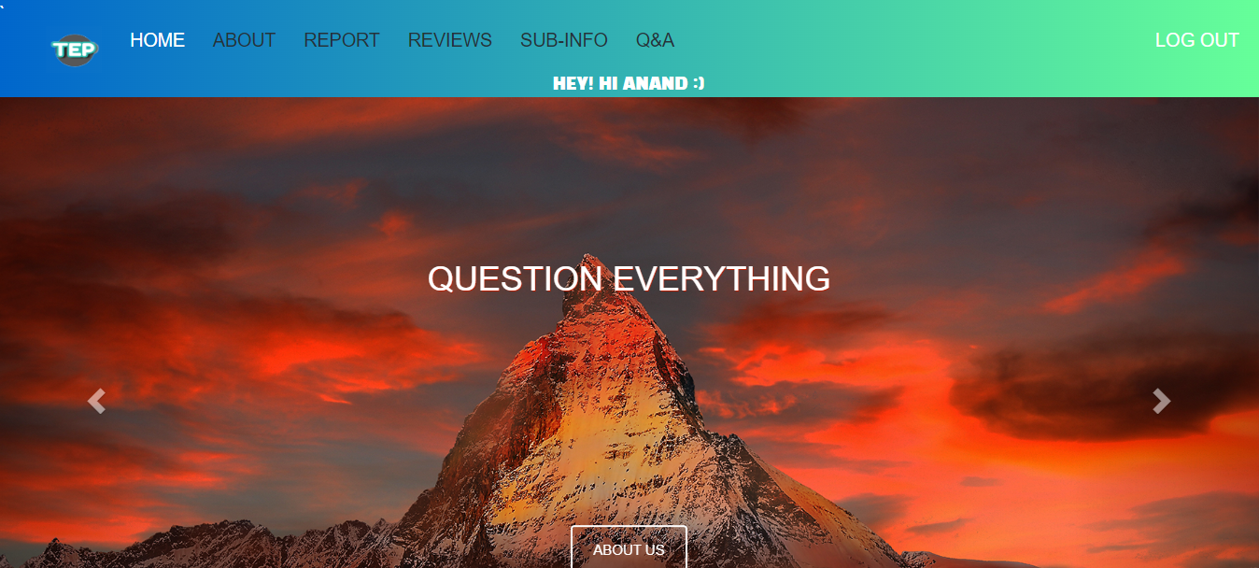

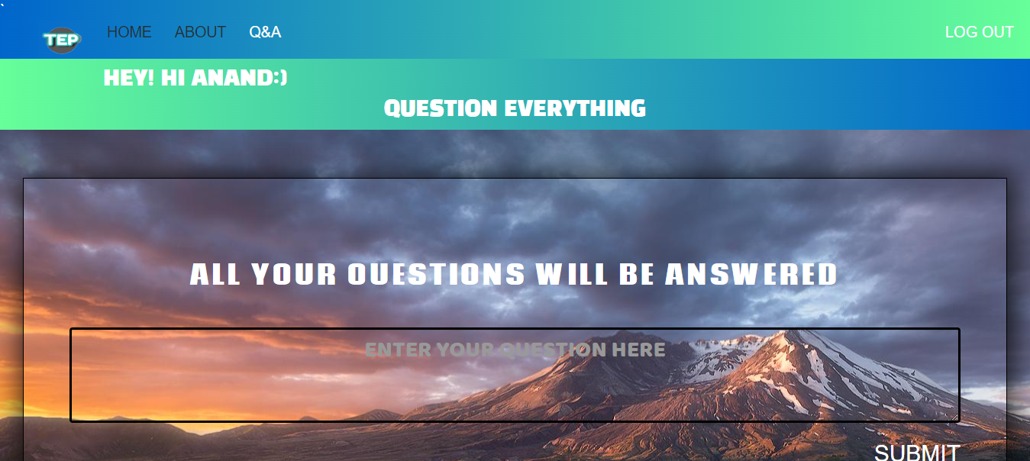

**REFERENCES**

* [www.google.com](http://www.google.com)
* [www.w3schools.com](http://www.w3schools.com)
* [www.geeksforgeeks.com](http://www.geeksforgeeks.com)
* [www.freefrontend.com](http://www.freefrontend.com)
* HTML,CSS and JS textbooks
* Udemy Basic Courses

**ABOUT MY TEAM**

**Team Mates:**

**Belliappa K E - 4MC18CS020**

**Anand Sunkad - 4MC18CS010**

We together putforth our effort in completing this project and achieving it within the due date given by the company. We had a great experience while conducting this project and learnt a new and interesting concepts.

**Roles in completing the project:**

**Anand Sunkad** – Designing a front-end for the webpage and provide styling and designs to the webpage

**Belliappa K E** – Creating the backend using JavaScript and connecting it to the front end and making this project a complete one.

**********************